**Build tool :**

Build tool basically does following automation

* Build tools creates deployment folder structure ( development tool might have diff folder types for developing . build tool might have diff folder types for building………………..
* Our code might depend on external dependencies, build tool must make sure those dependencies are in class part.
* Compile soure code
* It also can run test cases on your code
* Package

By executing single command all the above tasks are performed by build tool.

**Pom.xml**: it is a configuration file used by maven to perform all build related activities without pom.xml maven will not work.

**21-10-19**

**Creating maven based** java **project :** ( developpers will do it)

Installing maven on windows

Maven is written on java so JVM is a dependency

Maven also compile java code it’s also require JDK

Install Java development kit on windows (JDK)

Install Maven (<http://apachemirror.wuchna.com/maven/maven-3/3.6.2/binaries/apache-maven-3.6.2-bin.zip>)

Unzip it

We need to add maven to the path and we should tell maven where java is installed

Adding maven to the path

Go to start menu – search for edit environment for system variables – one dialog box appears – click on environment variables

Path – there paste the path of bin folder of extracted maven folder -ok-ok

Go to environment variables – click on Java-Home where java is available , there paste the path of java folder (c disk – program files – java we can see jdk1.8.0_231 – open and paste that path in java_home variable.

-----------------------CLASS MISSED ___________

**22/10/19**

**IQ) How to skip Junit test cases in Maven ?**

We have two ways to do that

* mvn package _Dmaven.test.skip=true

( developpers write a code ,some times test cases will fail , we can skip that and testing team will test that )

**Maven target folder ?**

(The target folder is created when we run maven commands)

Target folder is o/p folder of Maven , it is created when we run maven build commands, it is safe to delete (because it can be regenerated).

mvn clean package ( delete the target package)

mvn test

mvn package

mvn install

mvn deploy ( upload artifacts to remote repository )[ we need to configure nexus *D ………..

**-------------------------------------- Sonar type Nexus ----------------------------------**

* it is used for maven remote repositories
* it stores artifacts (after build what we get called artifact - (jar,war,ear (enterprise application archive) ) , artifacts are nothing but package format of our applictions

**IQ)** which artifactory you are using in your project?

* Sonartype Nexus.

**INSTALL AND CONFIGURE SONARTYPE NEXUS**

* It is written in java , jvm is a dependency
* Install and configure nexus on linux machine
* Connecting to Ec2
* Mobaxterm – it is used for connecting to remote servers like putty.
* Install sonartype nexus
* For installing and
* Install package on linux machine (Sudo yum install java | grep java-1.8.0

**23-10-19**

**Agile metholodology**

Scrum :

Sprint

2 to 4 weeks

Standup metting

Scrum master : to make sure every scrum member is

We need to give status in the standing meeting regarding what we have done and we are going to do.

Responsible for delivering the product on time

We will get the requirement from scrum master , scrum master interacts with product owner – scrum master interacts with BA guy,

BA should have idea on functional and technical knowledge.

Project management tool /bug tracking tool:

Jira – not an open source , owner is Atlas

Environments :

* Dev -----------------🡪Developers – we have end-to -end access once developers give sign off then it will move to test
* Test------------------🡪 we won’t give access to developers for test environment db.(it is completely for testers)[tester sign off required]
* Preprod/Uat-----🡪 if your code is working in one environment and not working In another environ means there will be configuration issue or DB issue. ( can be used by testers or BA or client ) [ product sign off required]
* Prod/live --------🡪

If we want to move from one env to another sign off required

Code mgmt tools :

SVN

GIT

Jar/war/ear -------🡪 packaging

For stand alone app we can use Jar

War is used for web application

Ear is used for e-commerce appliocation

1. Build

2. Deployment

Build tools : responsibility is creating a jar /war/ear

* Maven
* Ant
* Gradle

Deployement:

* Stop server
* Take backup existing Jar
* Copy the jar file in to the server
* Before starting any configurations are required we can do it
* Start the server

**Day12 24-10-19**

<https://github.com/javahometech/nexus/blob/master/README.md>

**Setting up Nexus on AWS Linux**

**SSH into Linux server**

Using putty or MobaXterm or any ssh client

**Install java**

sudo yum install java-1.8.0-openjdk -y

**Install Nexus 3**

cd /opt/

sudo wget https://download.sonatype.com/nexus/3/latest-unix.tar.gz

Untar the file

sudo tar xvf latest-unix.tar.gz

Change the ownership

sudo chown -R ec2-user:ec2-user nexus-3.19.1-01 sonatype-work

**Run nexus as a service**

**1 Change user for nexus**

open bin/nexus.rc and make sure the following line is present

run_as_user="ec2-user"

**2 Execute following command**

sudo ln -s /opt/nexus-3.19.1-01/bin/nexus /etc/init.d/nexus

cd /etc/init.d

sudo chkconfig --add nexus

sudo chkconfig --levels 345 nexus on

sudo service nexus start

**Loging to Nexus3 using browser**

http:public-ip:8081

and follow instructions to get access to nexus

**Store artifacts into nexus**

We are going to use following repositories to store artifacts

Nexus settings --> repositories

* maven-release
* maven-snapshots

**Under Maven configure Nexus details**

**1. Configure nexus user/password.**

Open maven settings($MAVEN_HOME/conf/settings.xml) file and add following snippet

<servers>

<server>

<id>nexusRepo</id>

<username>admin</username>

<password>javahome</password>

</server>

</servers>

**1. Configure pom.xml of your project**

Make suer the following snippet exists in pom.xml

<distributionManagement>

<snapshotRepository>

<id>nexusRepo</id>

<url>http://13.233.230.166:8081/repository/maven-snapshots/</url>

</snapshotRepository>

<repository>

<id>nexusRepo</id>

<url>http://13.233.230.166:8081/repository/maven-releases/</url>

</repository>

</distributionManagement>

(LDAP:

Server to place users

If I want to have access git hub , or laptop or Jenkins those are integrated to LDAP then we get the acess)

**Store artifacts in to nexus :**

We are using existing repostiries

Nexus settings page – repositories- create repository – maven2(hosted)

-maven-release

-maven-snapshots

### unser maven configure Nexus details

1. Configure Nexus user/password.

Open maven settings file and add following snippet

25-10-19

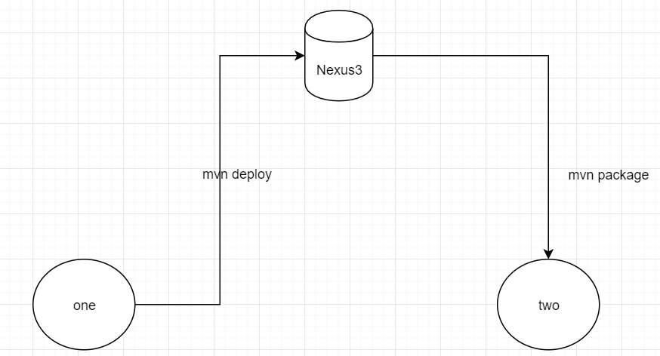

Git sources source code

Nexus is the code having ready to deploy

We can tag source code versions I can keep that in git

We can buil , package by nexus all deployments happens through nexus.

Nexus will have all versions , if present version fails we can roll back to previous version, we no need to go to source code(git)

Versioning the binary and give it to the customer but not source code

=========================================================================